

[](https://www.bing.com/images/search?view=detailV2&ccid=H8xAbX0N&id=5E9140CBAA9ECE40C78A9A03BA142592150CBE84&thid=OIP.H8xAbX0N4jaxy5yJ_EhNhAHaE7&mediaurl=https://personalexcellence.co/files/leaf.jpg&exph=533&expw=800&q=inspirational+phiotos&simid=608020664459462269&selectedIndex=189)

[](https://www.bing.com/images/search?view=detailV2&ccid=cE6upq9P&id=51A1ECBFEE63BC92AB1270D0DF9C730424BBDC30&thid=OIP.cE6upq9Pf2Uf7LRVar_adwHaFS&mediaurl=http://b50ym1n8ryw31pmkr4671ui1c64.wpengine.netdna-cdn.com/wp-content/blogs.dir/11/files/2011/04/Baby-Second-Sean-Crane-1024x731.jpg&exph=731&expw=1024&q=inspirational+phiotos&simid=608019620791127352&selectedIndex=71)



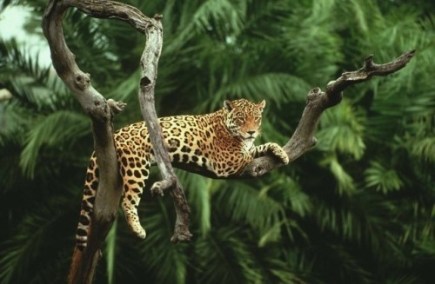[](https://www.bing.com/images/search?view=detailV2&ccid=jZ2tN4Pk&id=E1E3BEB1F5B0A5851FDD6A659AB83CBE22C11022&thid=OIP.fUU5GYQQ9ISWwyJ1XPGu9gHaE8&mediaurl=http://www.fubiz.net/wp-content/uploads/2014/12/Inspiring-Lifestyle-Photography-3.jpg&exph=427&expw=640&q=inspirational+phiotos&simid=607997514618634271&selectedIndex=124)